Home SOC Project
Summary
I built a basic log collection setup on my Windows laptop using Sysmon + Splunk, then created simple reports to review process activity, DNS lookups, and registry changes.

Goal
Get hands-on practice collecting logs and using Splunk to answer basic investigation questions like:
- What ran on the system?
- What domains were looked up?
- What registry settings were changed?

Tools used
- Windows 11
- Sysmon (Sysinternals)
- Splunk Enterprise (local install)

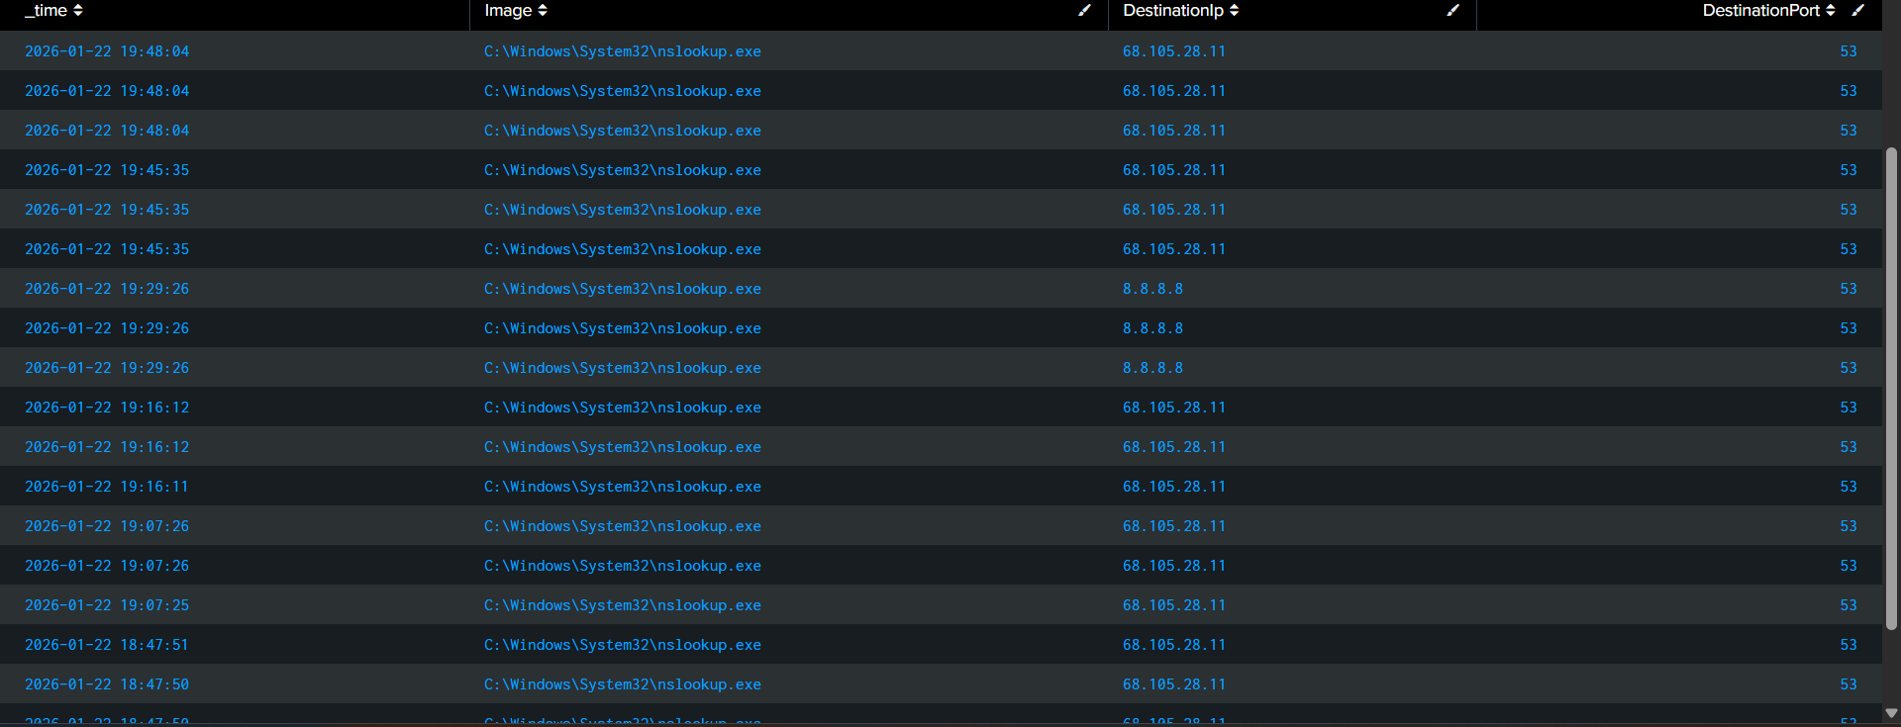
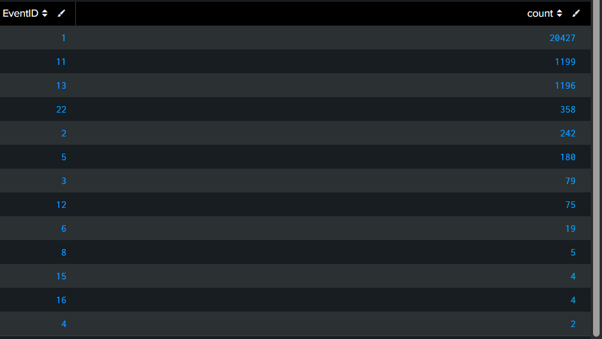
What I set up
- Installed Sysmon to generate detailed Windows activity logs
- Configured Splunk to ingest Sysmon logs (Sysmon/Operational)
- Verified data was coming in and created reports to review the activity

Evidence (what I observed)
- nslookup.exe generated outbound connections to DNS resolvers over port 53.
- Destination IPs observed included 68.105.28.11 and 8.8.8.8.
Why this matters (SOC relevance)
This demonstrates process-to-network attribution, which is used in investigations to determine what program initiated what network traffic, a common first step in identifying suspicious outbound activity.

DNS Reports (Event ID 22)
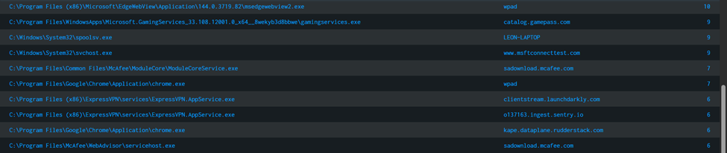
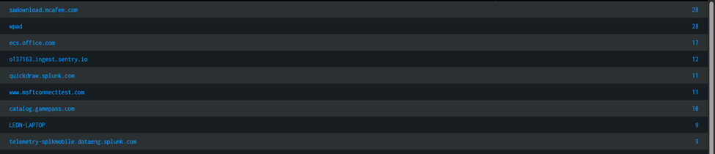
Summary
Used Sysmon DNS logs in Splunk to see what domains my computer was looking up and which apps were responsible.
What I did
- Collected Sysmon DNS events (EventID 22) into Splunk.
- Built a “Top Domains” report to quickly see the most common lookups.
- Built a “DNS by App” report to connect domains back to the program that requested them.
Why it matters
If something suspicious happens, this helps answer two basic questions fast:
- “What domain did the computer try to reach?”
- “What program tried to reach it?”
What I learned
Seeing domain activity is helpful, but seeing the process behind it is what really makes it useful for investigations.

Basic Process Hunting (Sysmon EventID 1)
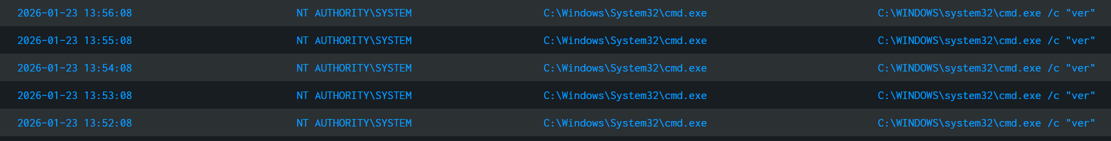

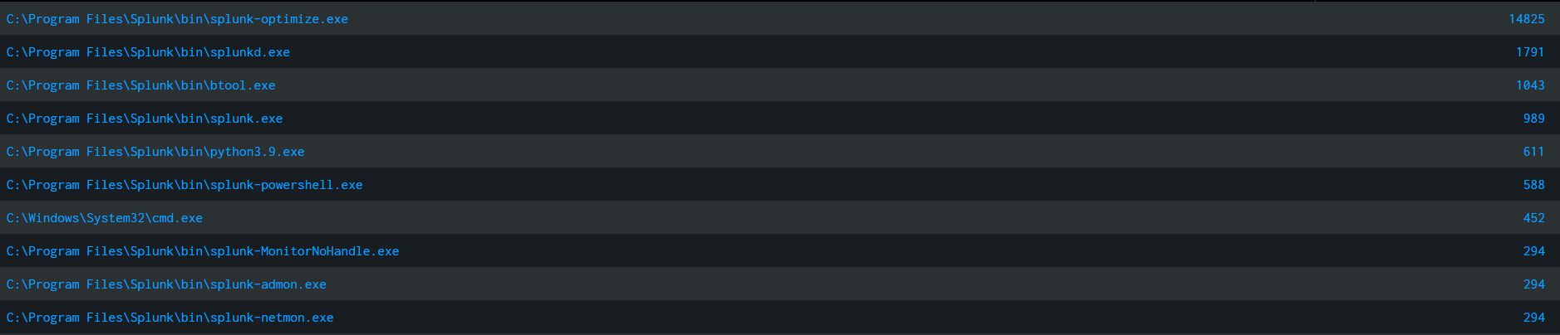
Summary
Used Sysmon process logs in Splunk to spot command-line activity and build a simple baseline of what runs most on my PC.
What I did
- Built a report focused on command-line tools (PowerShell/cmd/etc.) so I could quickly review what commands were being run.
- Built a “top processes” baseline to understand normal activity.
Why it matters
Command-line activity is often where investigations start, and having a baseline makes it easier to notice something that looks out of place.

Registry Monitoring (Sysmon EventID 13)
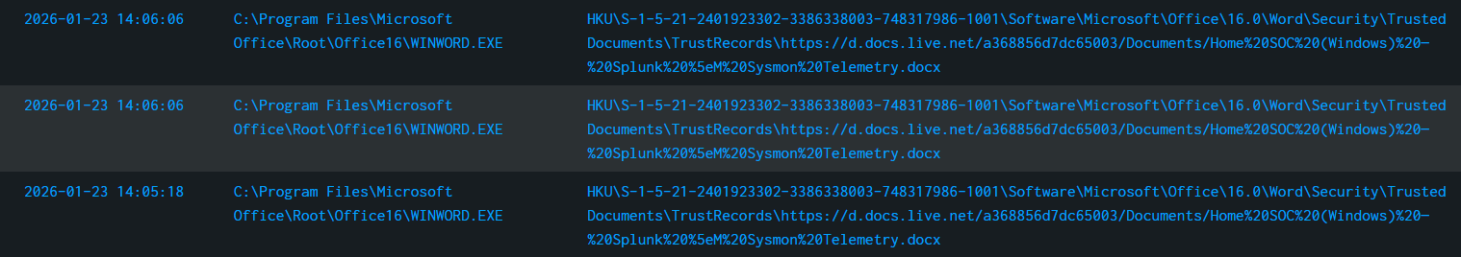
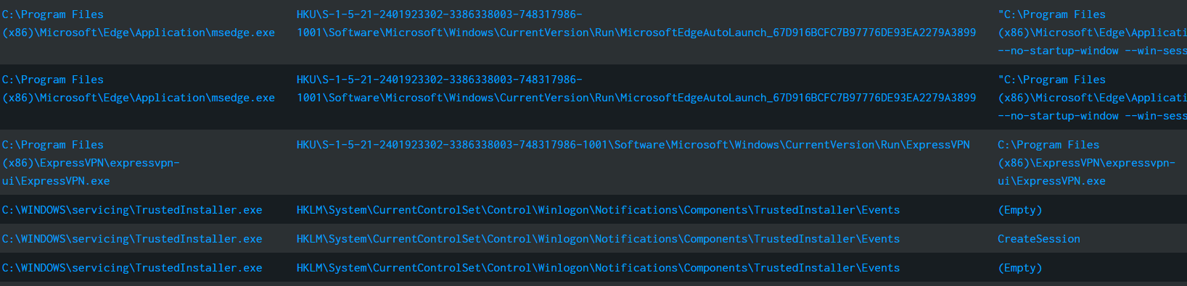
summary
Used Sysmon registry change logs in Splunk to see what registry values were modified and which programs made the changes.
What I did
- Built a report showing recent registry value updates (EventID 13).
Why it matters
Registry changes can be normal, but they can also be a sign of something trying to set itself to run automatically. This report helps narrow down what changed and where to look first.
What I learned:
Even normal apps can change startup-related registry settings, so it’s important to check what changed, where, and which program did it before assuming it’s malicious.

